Unemployment Insurance (UI) Nonmonetary Determinations
1st Quarter of 2022
Workload

In the 1st quarter of 2022, the number of UI nonmonetary determinations increased 1.5% from the previous quarter. The number of separation determinations remained at 4.5% and the number of nonseparation determinations decreased by 0.0%. However, even though these categories show increases in this quarter, workload remains slightly higher than the same quarter in 2020 due to the impact of Covid-19 on state workload.

In the 1st quarter of 2022, 56.1% of the determinations involving separation issues resulted in a denial of UI benefits, and 43.9% of the determinations concluded that the claimant was eligible for benefits. This ratio in the 1st quarter of 2022 is concluding that most determinations claimants are not eligible for benefits.

In the 1st quarter of 2022, 89.2% of the determinations involving nonseparation issues resulted in a denial of UI benefits, while the claimant was found to be eligible for benefits in only 10.8% of nonseparation determinations. Although workload increased significantly starting with the 2nd quarter of 2020 due to the impact of Covid-19, the ratio of denials to eligible claims remains similar for nonseparation issues.
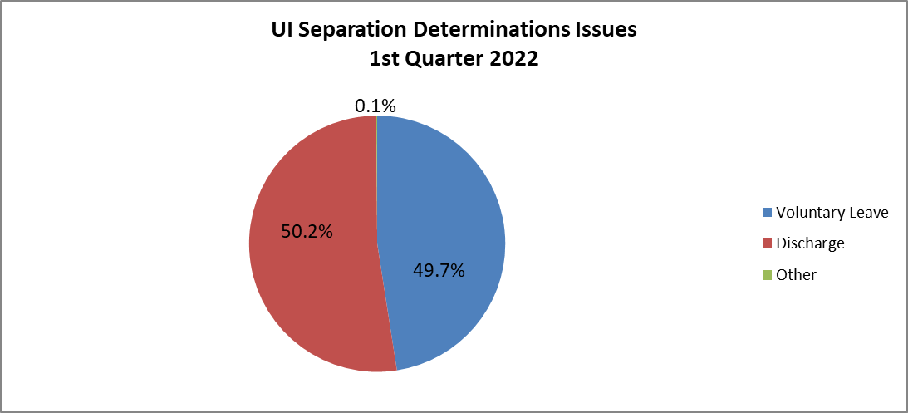
In the 1st quarter of 2022, 52.4% of the determinations involving separation issues due to discharge, 47.5% were due to voluntary leave, and 0.1% due to other reasons. This differs from results in 2019 and earlier, where separations due to discharge accounted for the majority of separation types.

In the 1st quarter of 2022, 79.6% of the determinations where the claimant voluntary left the job, resulted in a denial of eligibility. In contrast, states issued denials for only 34.8% of the determinations where the claimant was discharged from the job.
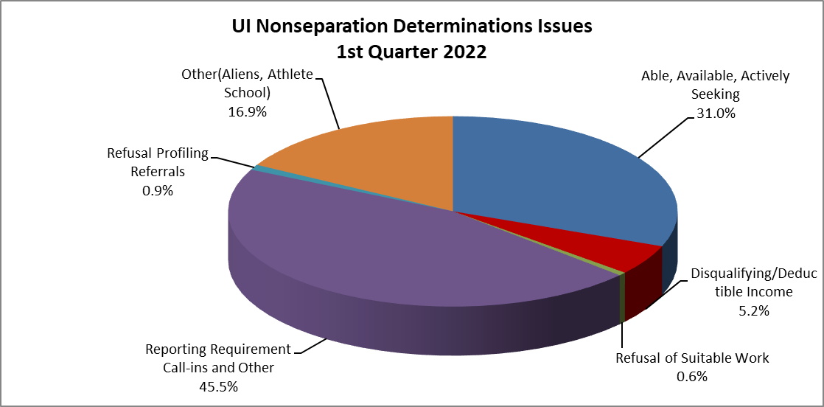
In the 1st quarter of 2022, the largest category of nonseparation determinations (45.5%) was the reporting requirement call-ins and other. The second largest category (31%) was able, available, actively seeking employment. This differs from 2019 and earlier, where the largest category was “able, available, actively seeking” and the second largest category was “reporting requirement, call-ins and other”.
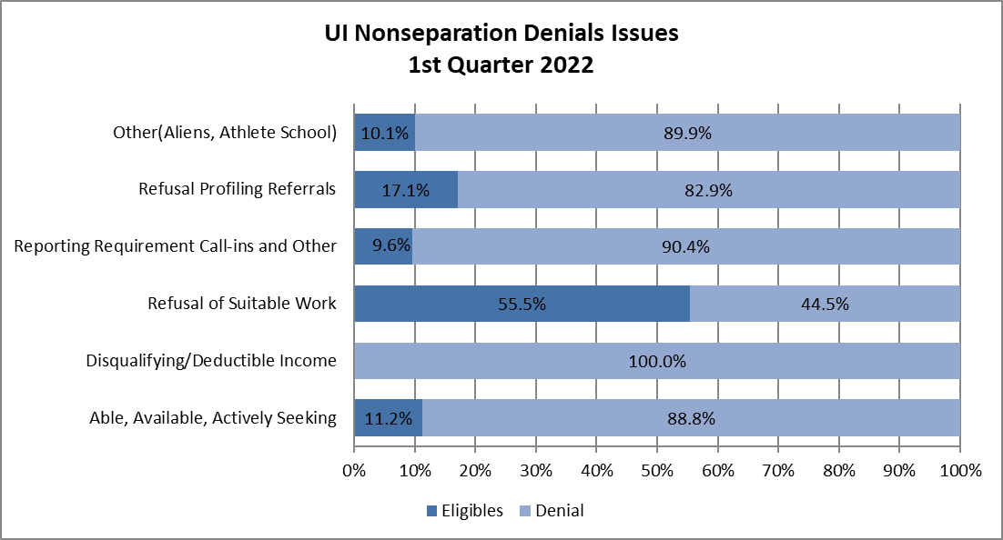
In the 1st quarter of 2022, the category of nonseparation determinations with the highest denial rate was “Disqualifying/Deductible Income” with 100%, followed by “Reporting Requirement Call-ins and Other” with 90.4% and “Other (Aliens, Athlete School)” with 89.9%.
This report was produced on 7/26/2022 by the Office of Unemployment Insurance, Division of Performance Management.

