Unemployment Insurance (UI) Nonmonetary Determinations
1st Quarter of 2023
Quality
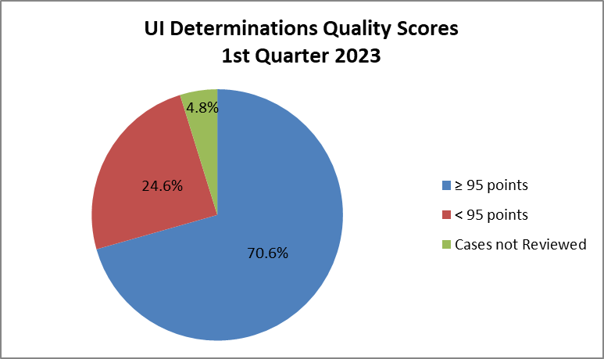
In the 1st quarter of 2023, 70.6% of the nonmonetary determinations sampled and reviewed for quality passed validation with 95 or more points out of 100, and 24.6% failed to meet that standard.
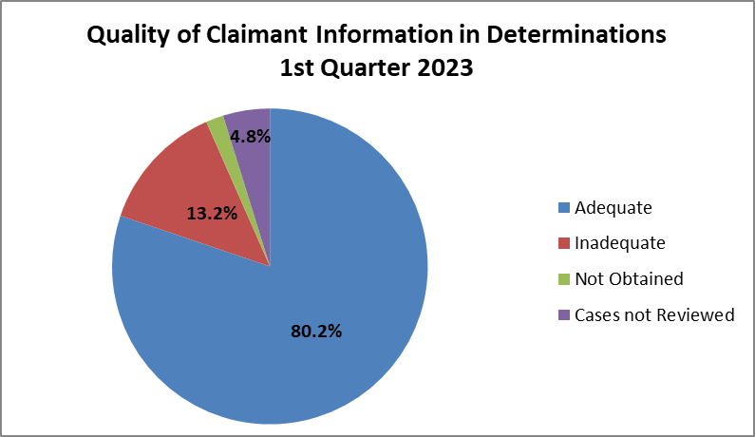
In the 1st quarter of 2023, the quality of claimant information was adequate for 80.2% of the nonmonetary determinations sampled and reviewed.
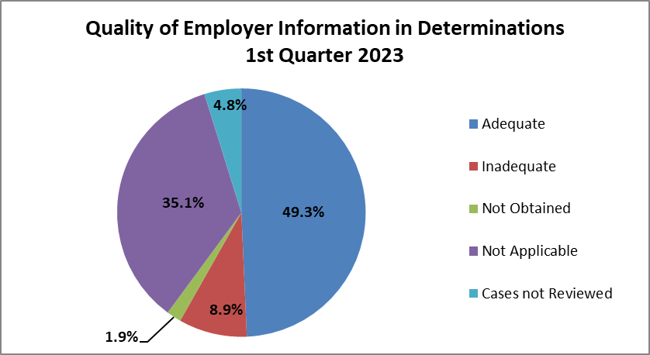
In the 1st quarter of 2022, the quality of the employer information was adequate for 49.3% of the nonmonetary determinations sampled and reviewed.
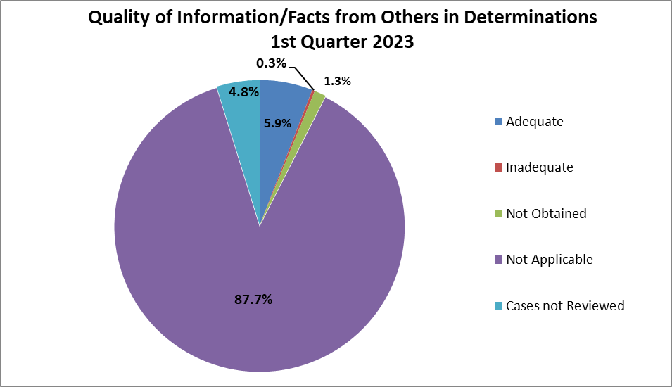
In the 1st quarter of 2023, the quality of the information and facts obtained from others (for example labor unions, private employment agencies, employer representatives) was adequate for 5.9% of the nonmonetary determinations sampled and reviewed.
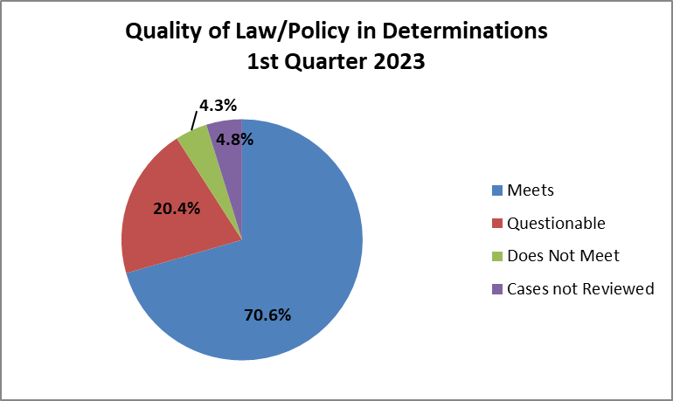
In the 1st quarter of 2023, the quality reviews concluded that 70.6% of the nonmonetary determinations sampled met the standards for the application of law and policy. A nonmonetary determination meets the standard if “all relevant and critical facts were obtained or a reasonable attempt was made to obtain them and the nonmonetary determination is clearly correct.” (ET Handbook 301, UI Performs: Benefits Timeliness and Quality Nonmonetary Determinations Quality Review)
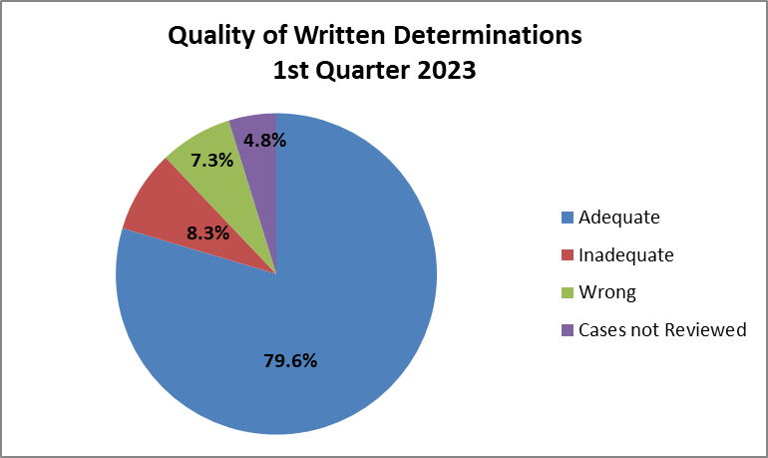
In the 1st quarter of 2023, the quality of the written determination was adequate for 79.6% of the nonmonetary determinations sampled and reviewed.

This report was produced on 06/16/2023 by the Office of Unemployment Insurance, Division of Performance Management.

