Unemployment Insurance (UI) Nonmonetary Determinations
1st Quarter of 2023
Workload
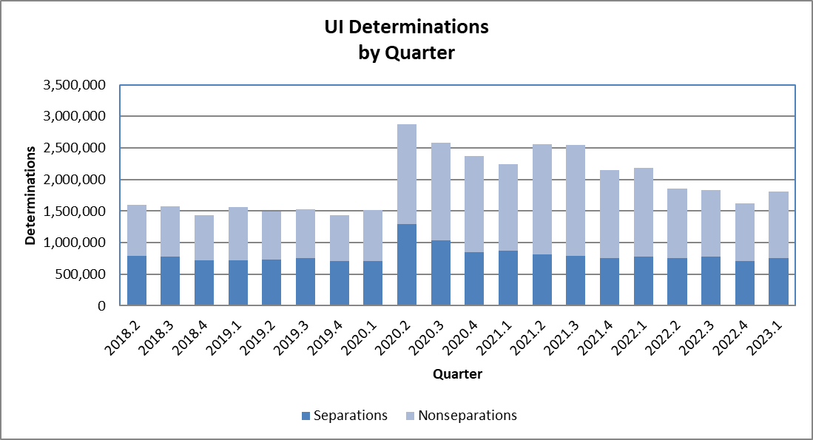
In the 1st quarter of 2023, the number of UI nonmonetary determinations increased 11.7% from the previous quarter. The number of separation determinations increased by 6.1% from previous quarter and the number of nonseparation determinations increased by 16.1%. However, even though these categories show increases in this quarter, workload also is showing a significant decrease compared to the same quarter in 2020 due to the impact of Covid-19 on state workload.

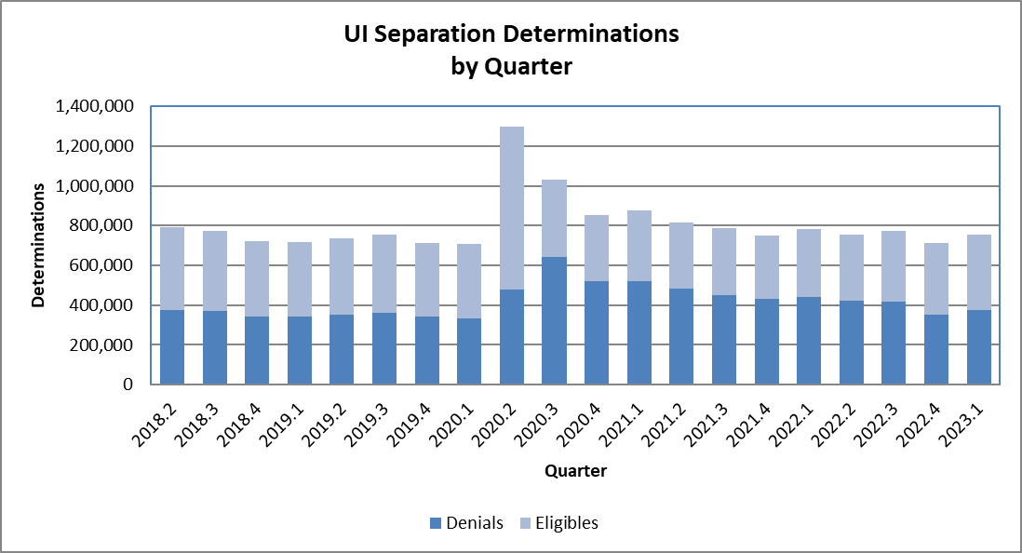
In the 1st quarter of 2023, 49.4% of the determinations involving separation issues resulted in a denial of UI benefits, and 50.6% of the determinations concluded that the claimant was eligible for benefits. This ratio in the 1st quarter of 2023 is concluding that half of determinations claimants are both eligible and not eligible for benefits.
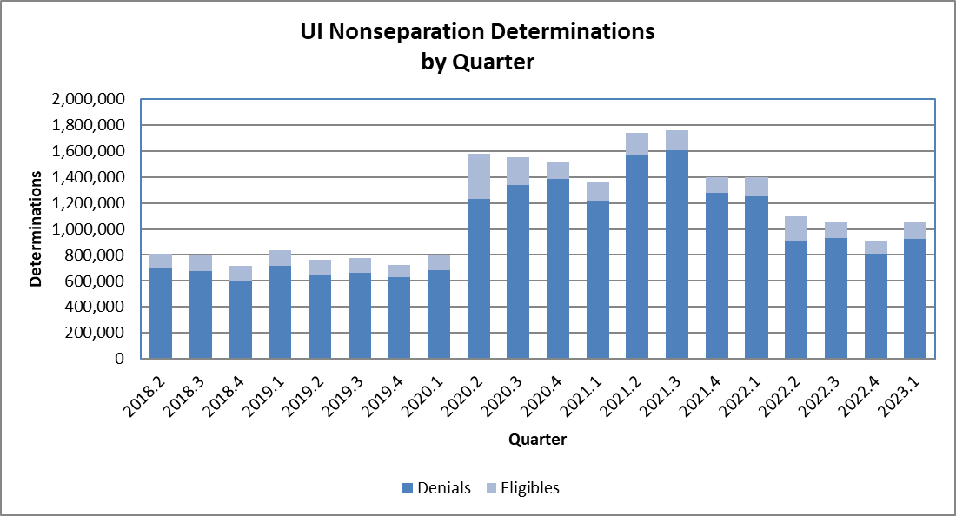
In the 1st quarter of 2023, 87.5% of the determinations involving nonseparation issues resulted in a denial of UI benefits, while the claimant was found to be eligible for benefits in only 12.5% of nonseparation determinations. Although workload increased significantly starting with the 2nd quarter of 2020 due to the impact of Covid-19, the ratio of denials to eligible claims remains similar for nonseparation issues.
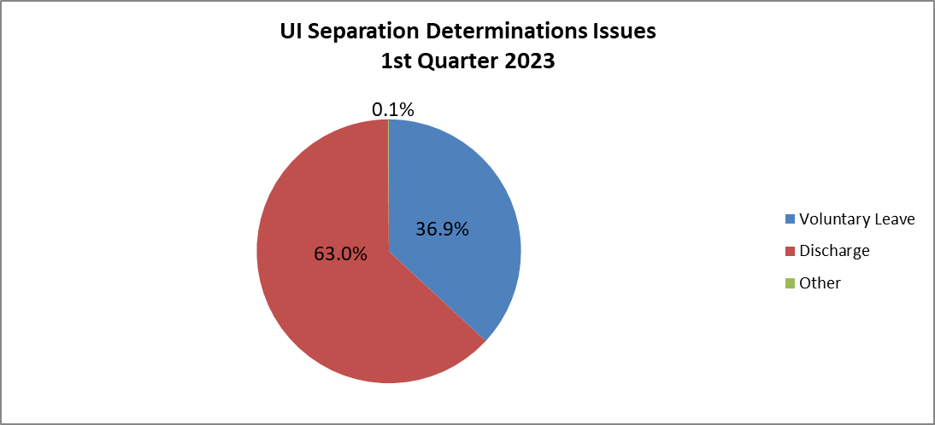
In the 1st quarter of 2023, 63.0% of the determinations involving separation issues due to discharge, 36.9% were due to voluntary leave, and 0.1% due to other reasons. This differs from results in 2019 and earlier, where separations due to discharge accounted for the majority of separation types.
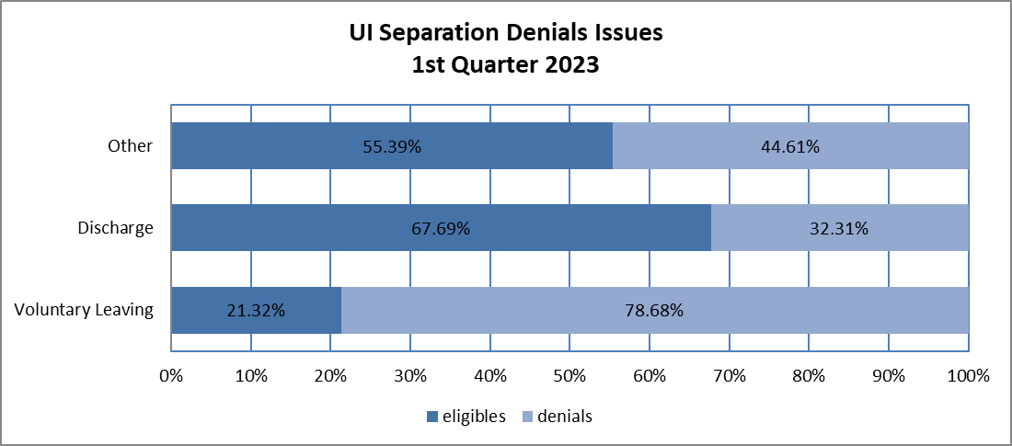
In the 1st quarter of 2023, 78.7% of the determinations where the claimant voluntary left the job, resulted in a denial of eligibility. In contrast, states issued denials for only 32.3% of the determinations where the claimant was discharged from the job.
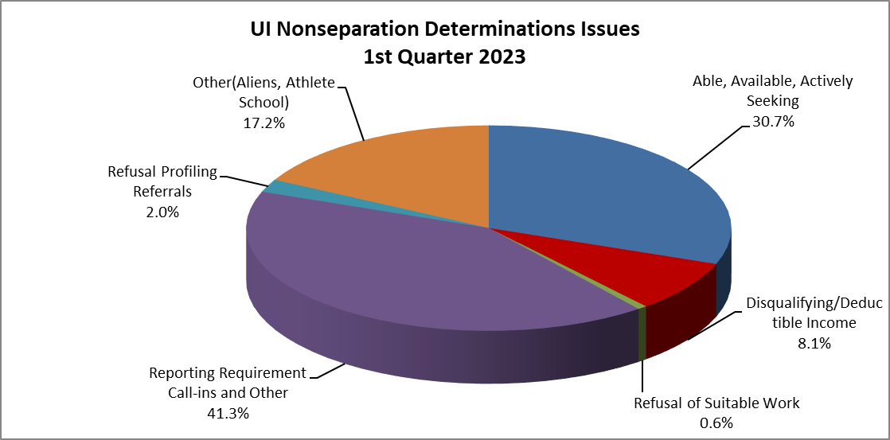
In the 1st quarter of 2023, the largest category of nonseparation determinations (41.3%) was the reporting requirement call-ins and other. The second largest category (30.7%) was able, available, actively seeking employment. This is unlike 2019 and earlier, where the largest category was “reporting requirement, call-ins and other” and the second largest category was “able, available, actively seeking”.
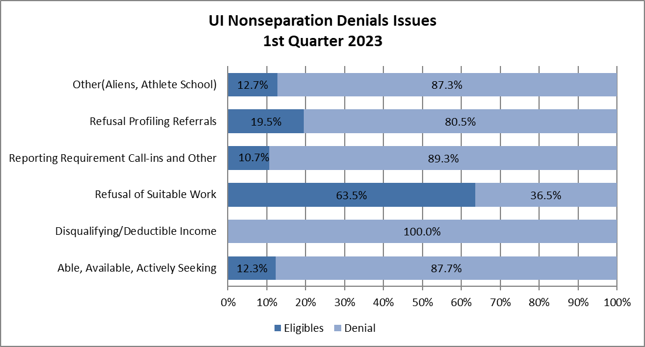
In the 1st quarter of 2023, the category of nonseparation determinations with the highest denial rate was “Disqualifying/Deductible Income” with 100%, followed by “Reporting Requirement Call-ins and Other” with 89.3% and “Able, Available, Actively Seeking” with 87.7%.
This report was produced on 06/16/2023 by the Office of Unemployment Insurance, Division of Performance Management.

